THE FIRST V8 SUPERCARS GAME
WAS A BEST SELLER!


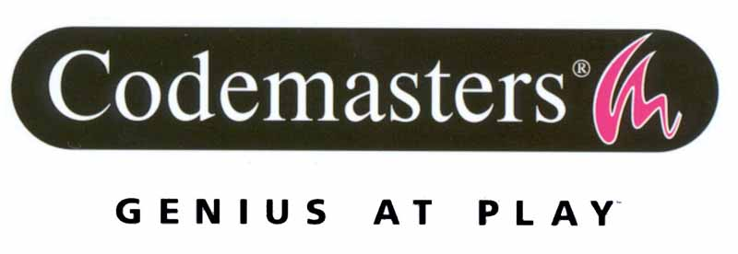

V8 SUPERCAR RACE DRIVER SALES LEAD THE PACK

Sydney, 10th September 2002 – Atari, Australia’s premier source of interactive software, proudly announces record sales of Codemasters’ V8 Supercar Race Driver in its first week of release.

V8 Supercar Race Driver has exceeded all expectations in its first week of release becoming the fastest selling PlayStation 2 game of all time. Since its official release date of 27th August 2002, V8 Supercar Race Driver sold over 25,000 copies*.

Anticipation was at fever pitch as V8 Supercar Race Driver hit the shelves, with many stores selling out their entire stock on the day of release. Mark Gilbert, Group Marketing Manager for Atari Australia said, “We are absolutely delighted with the sales of V8 Supercar Race Driver in its first week, and would like to thank our retail partners for the tremendous support they have given to this game. With the on going marketing support and the quality of the game we believe V8 Supercar Race Driver should be topping the charts through to Christmas"

Phil Burnham, Research Manager for INFORM (the interactive industry’s sales tracking organisation), confirmed the magnitude of the demand for V8 Supercar Race Driver, "It's the biggest week ever for a PS2 game, AND the fastest selling PS2 game ever. It's quite probably the fastest selling game of all time (all platforms) within Australia, it certainly is since our weekly sales recording started (May 2001)"

V8 Supercar Race Driver was lauded for its authentic and gritty depiction V8 racing. Superb graphics combined with realistic damage modeling and a gripping story mode offered gamers a chance of experiencing the adrenaline rush of racing V8 cars through a variety of Australian tracks.

Tony Cochrane, Chairman of AVESCO, the V8 Supercars governing body, commented, “It has certainly been worth the wait and the popularity and demand for the game is just nothing short of phenomenal. I know from the overwhelming fan response we have had that the game has been extremely well received and we look forward to it being the biggest selling game in Australia's history.”

* INFORM sales data up to 01/09/02.

For further information contact:-

Chris Eade
Public Relations Manager
Atari Australia
Phone: (02) 8303 6832
Email: chris.eade@atari.com

